Date of Experiment : …………... Experiment No……….

Faculty Signature………. Roll No.00324402013

**AIM:** Design tables as follows:

|  |  |  |  |
| --- | --- | --- | --- |
| Roll no | Name | Course | Marks |
| 1 | Ajay Kumar | BBA | 78 |
| 2 | Kavita Sharma | BCA | 62 |
| 3 | Rohit Garg | BBA CAM | 87 |
| 4 | Pooja Kapoor | BBA | 67 |
| 5 | Mohit Gupta | BBA CAM | 72 |

**CODING:**

<html>

<head>

<title>Q7_rno_003 </title>

</head>

<body>

<table border=5 align="Center" Cellspacing="4" Cellpadding="6">

<tr>

<th>roll no</th>

<th>name</th>

<th>course</th>

<th>marks</th>

</tr>

<tr>

<td>1</td>

<td>Ajay Kumar</td>

<td>BBA</td>

<td>78</td>

</tr>

<tr>

<td>2</td>

<td>Kavita Sharma</td>

<td>BCA</td>

<td>62</td>

</tr>

<tr>

<td>3</td>

<td>Rohit Garg</td>

<td>BBA CAM</td>

<td>87</td>

</tr>

<tr>

<td>4</td>

<td>Pooja Kapoor</td>

<td>BBA</td>

<td>67</td>

</tr>

<tr>

<td>5</td>

<td>Mohit Gupta</td>

<td>BBA CAM</td>

<td>72</td>

</tr>

</table>

</body>

</html>

**OUTPUT:**

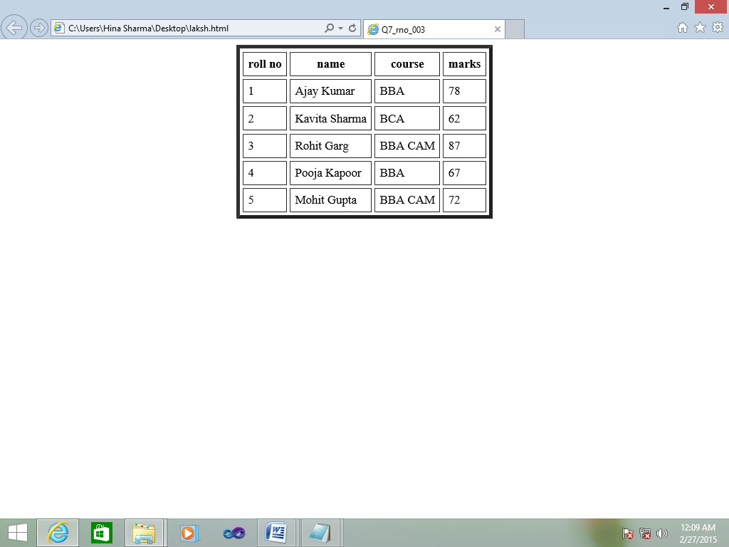

Date of Experiment : …………... Experiment No……….

Faculty Signature………. Roll No.00324402013

**AIM:** . . Design following HTML form:

**CODING:**

<html>

<head>

<title>ques 13 003</title>

</head>

<body>

<h2 align="center"><u>Employee Form</u></h2>

<form>

<pre>

Name <input type="text" name="n1">

Designation <select name="des">

<option>Select Any Option</option>

<option>Manager</option>

<option>Department Head</option>

<option>Engineer</option>

<option>Clerk</option>

</select>

Salary <input type="password" name="pwd">

Specification <input type="radio" name="r1" value="IT">IT <input type="radio" name="r1" value="Management">Management

Hobbies <input type="checkbox" name="c1" value="Travelling">Travelling <input type="checkbox" name="c1" value="Sports">Sports

<input type="checkbox" name="c1" value="Reading">Reading <input type="checkbox" name="c1" value="Net surfing">Net surfing

Address

<textarea name="a1" rows=5 cols=20>

</textarea>

<input type="submit" value="submit"> <input type="reset" value="reset">

</form>

</body>

</html>

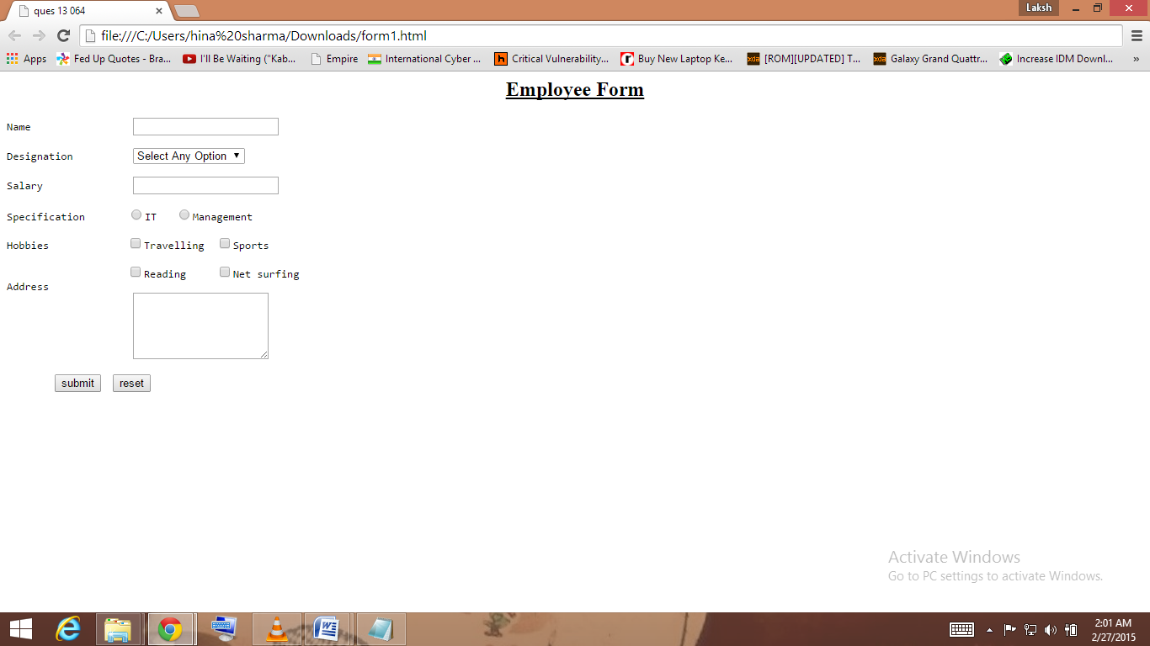

Date of Experiment : …………... Experiment No……….

Faculty Signature………. Roll No.00324402013

**AIM:** Design following frame:

|  |  |
| --- | --- |
| PRODUCTS  Mobile Phone Shoes Pen Drive Shirt | |
| Image | Description (Product code, Name, Brand, Price, Color, Discount, Offer/Scheme etc.) |

Mobile phone, shoes, Pen drive, Shirt will be hyperlinks. If user clicks on any item, its picture should be displayed in frame 2 and details about the product in frame 3.

**CODING:**

**Main:**

<html>

<head>

<title>Ques10</title>

</head>

<frameset rows="50%,50%">

<frame src="frame1.html" name="f1">

<frameset cols="50%,50%">

<frame name="f2">

<frame name="f3">

</frameset>

</frameset>

</html>

**Product:**

<html>

<head>

<title>frame1</title>

</head>

<body>

<h3 align="center">PRODUCTS</h3>

<pre>

<a href="mobile.html" target="f1">Mobile Phone</a> <a href="shoes.html" target="f1">Shoes</a> <a href="pd.html" target="f1">Pen Drive</a> <a href="shirt.html" target="f1">Shirt</a>

</pre>

</body>

</html>

**Mobile Phones:**

<html>

<head>

<title>Mobile Phones</title>

<body>

<a href="d1.html" target="f3"><img src="untitled.png" target="f2" height=300 width=300></a>

</head>

</html>

**Shoes:**

<html>

<head>

<title>Shoes</title>

<body>

<a href="d2.html" target="f3"><img src="dd.png" target="f2" height=300 width=300></a>

</head>

</html>

**Pen drive:**

<html>

<head>

<title>Pen drive</title>

<body>

<a href="d3.html" target="f3"><img src="as.png" target="f2" height=300 width=300></a>

</head>

</html>

**Shirts:**

<html>

<head>

<title>shirts</title>

<body>

<a href="d4.html" target="f3"><img src="fds.png" target="f2" height=300 width=300></a>

</head>

</html>

**OUTPUT:**

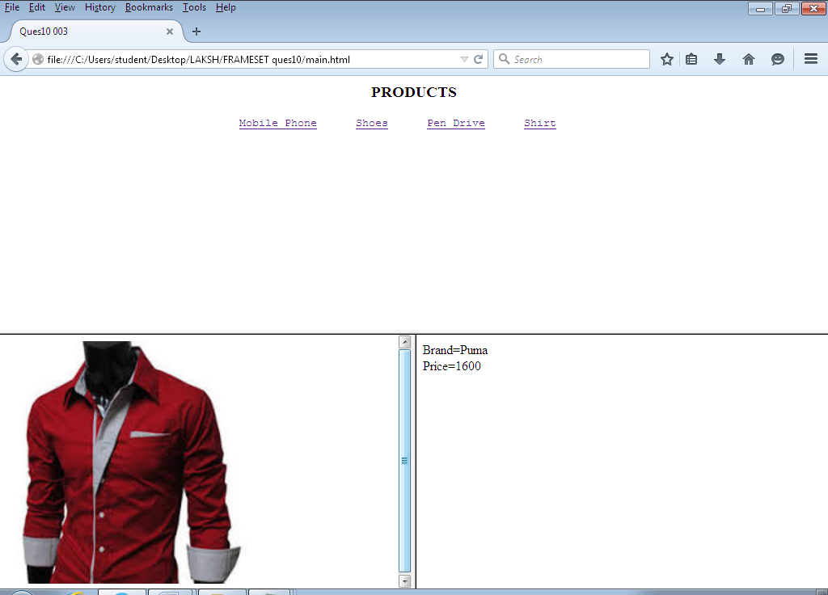

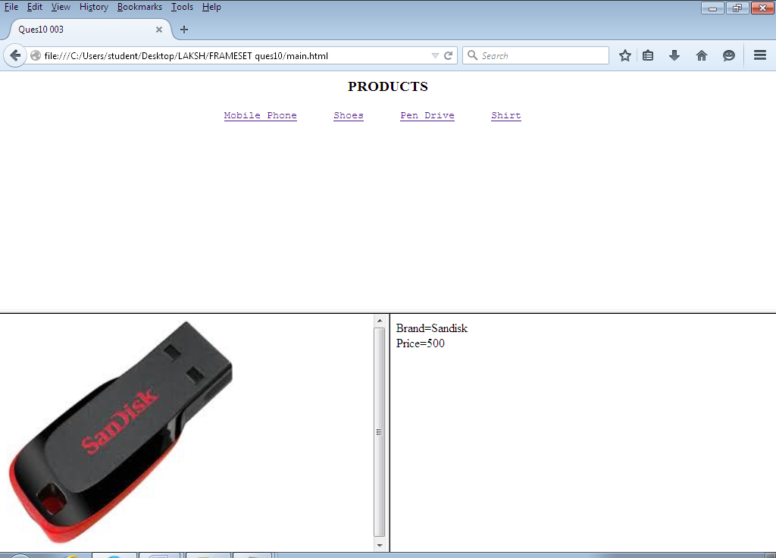

**CASCADING STYLE SHEET**

**Inline**

<html>

<body>

<p style="background: blue; color: white; font-size: 20pt; ">

Cascading Style Sheets (CSS) is a style sheet language used for describing the presentation semantics (the look and formatting) of a document written in a markup language.

In simpler words, Cascading Style Sheets (CSS) is a simple mechanism for adding style (e.g., fonts, colors, spacing) to Web documents.

It is designed primarily to enable the separation of document content (written in HTML or a similar markup language) from document presentation, including elements such as the layout, colors, and fonts

</p>

<h1 style="color:red; text-align:right; "> Heading style 1 </h1>

</body>

</html>

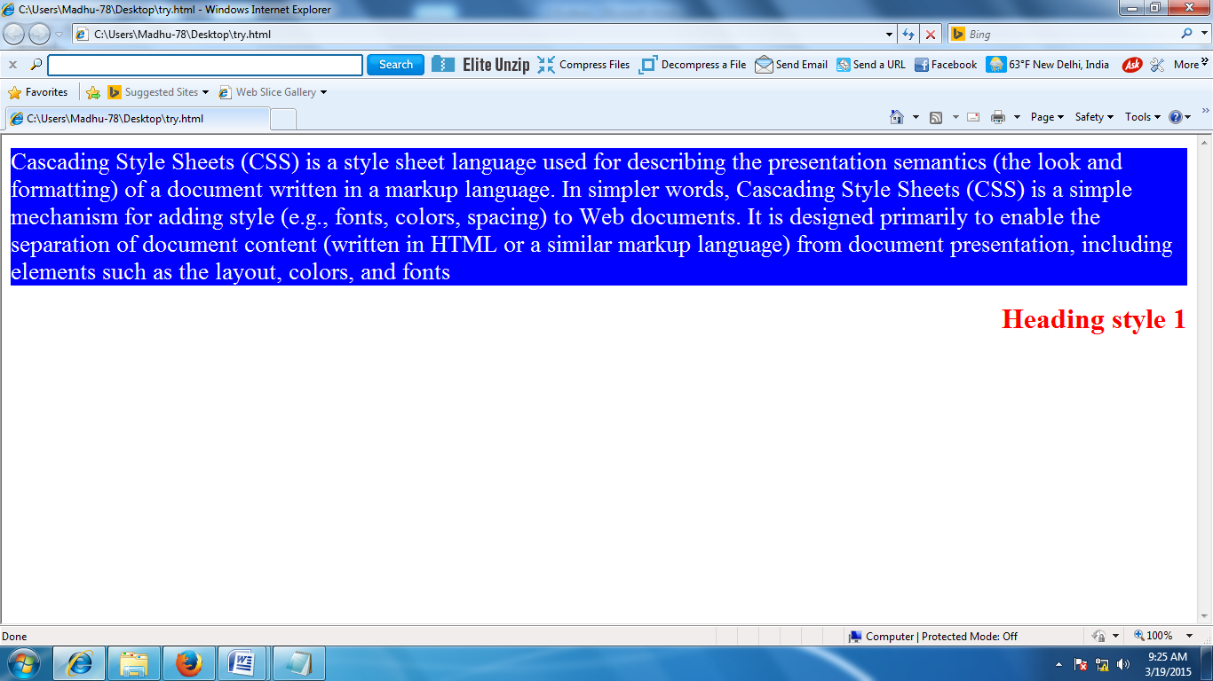

**Embedded**

<html>

<head>

<style type="text/css">

hr {color:red;}

p {margin-left:20px;}

body {background-image:url("C:\Users\Public\Pictures\Sample Pictures\Tulips.jpg");}

</style>

<body>

<p>Cascading Style Sheets (CSS) is a style sheet language used

for describing the presentation semantics (the look and formatting)

of a document written in a markup language.

</p>

<hr>

</body>

</html>

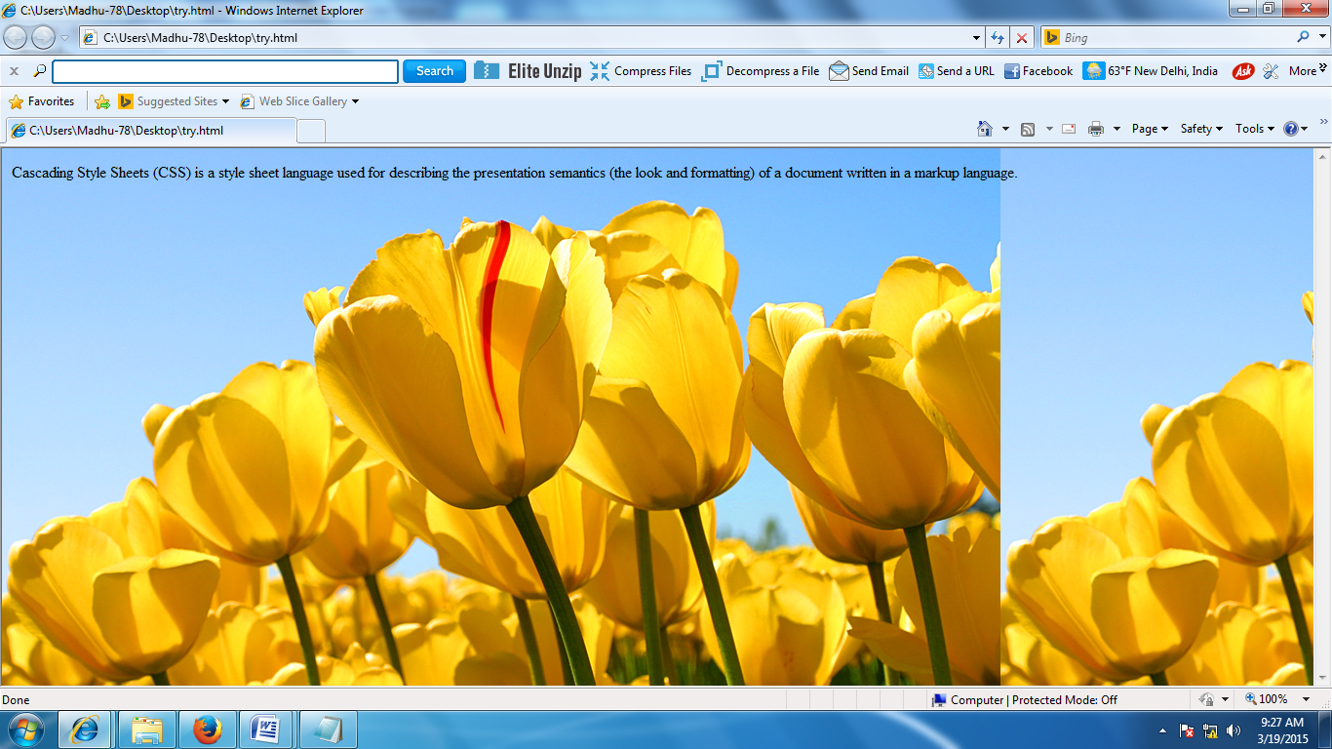

**External**

**Notepad 1**

p {margin-left:20px;}

body {background-color:red;}

hr {color:blue;}

**Notepad 2**

<html>

<head>

<link rel="stylesheet" type="text/css" href="style.css">

</head>

<body>

<p> hello</p>

<hr>

</body>

</html>

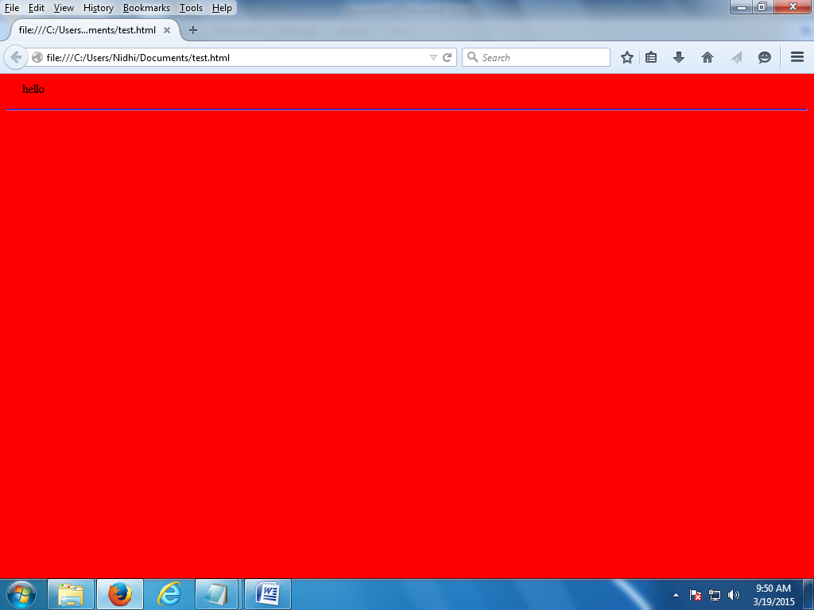

**Answer 4:**

<html>

<head>

<style type="text/css">

body

{background-image:url("C:\Users\Public\Pictures\Sample Pictures\Tulips.jpg");

background-repeat: no-repeat; background-position:center;}

</style>

<body>

Cascading Style Sheets (CSS) is a style sheet language used

for describing the presentation semantics (the look and formatting)

of a document written in a markup language.

</body>

</html>

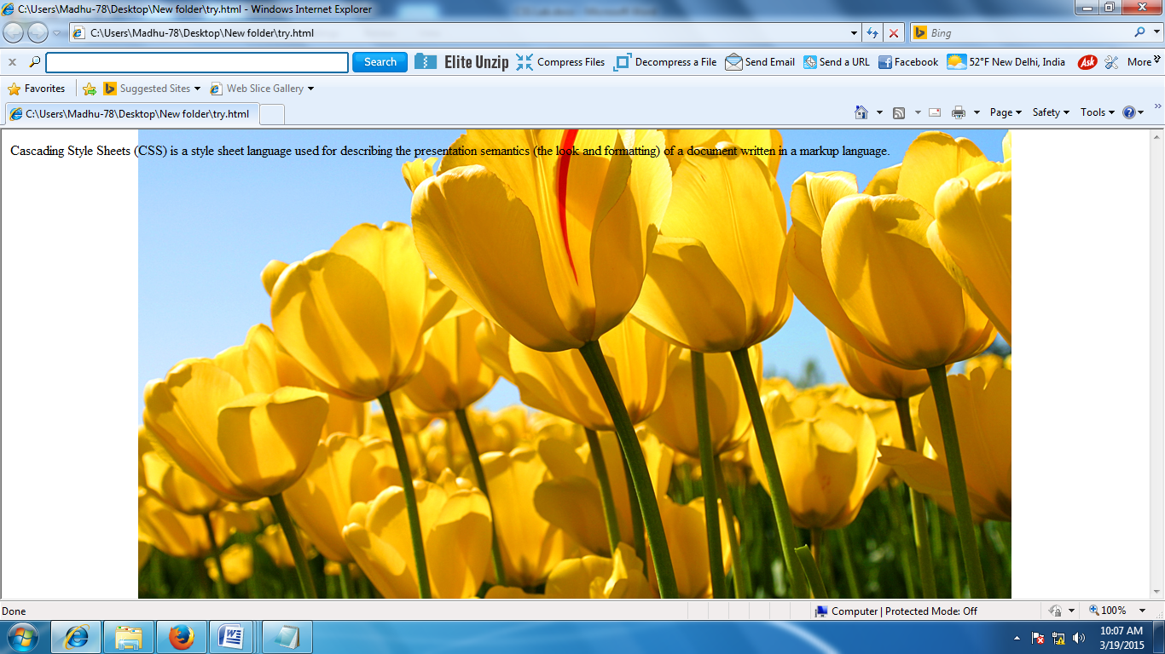

Ans 5

<html>

<head>

<style type="text/css">

p{font-size:40px;font-style:normal;font-weight:bold}

</style>

<body>

<p style="font-family:Comic Sans MS;">

Cascading Style Sheets (CSS) is a style sheet language used

for describing the presentation semantics (the look and formatting)

of a document written in a markup language.

</p>

</body>

</html>

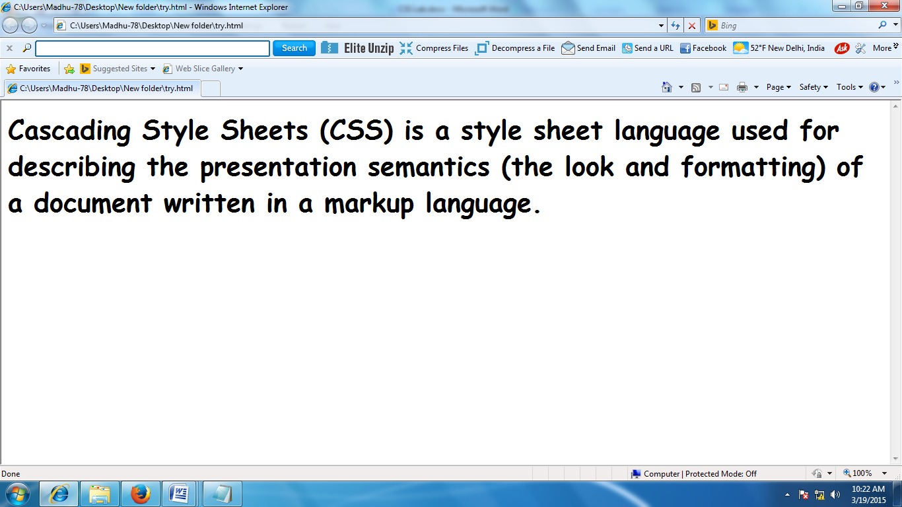

Ans 7

<html>

<head>

<style>

#para1

{text-align:center;color:green;font-size:50;font-family:times;}

.a

{text-align:right;color:red;font-size:30;font-family:times;}

</style>

</head>

<body>

<p id="para1">Cascading Style Sheets (CSS) is a style sheet language used

for describing the presentation semantics (the look and formatting)

of a document written in a markup language.

</p>

<p class="a">Cascading Style Sheets (CSS) is a style sheet language used

for describing the presentation semantics (the look and formatting)

of a document written in a markup language.

</p>

</body>

</html>

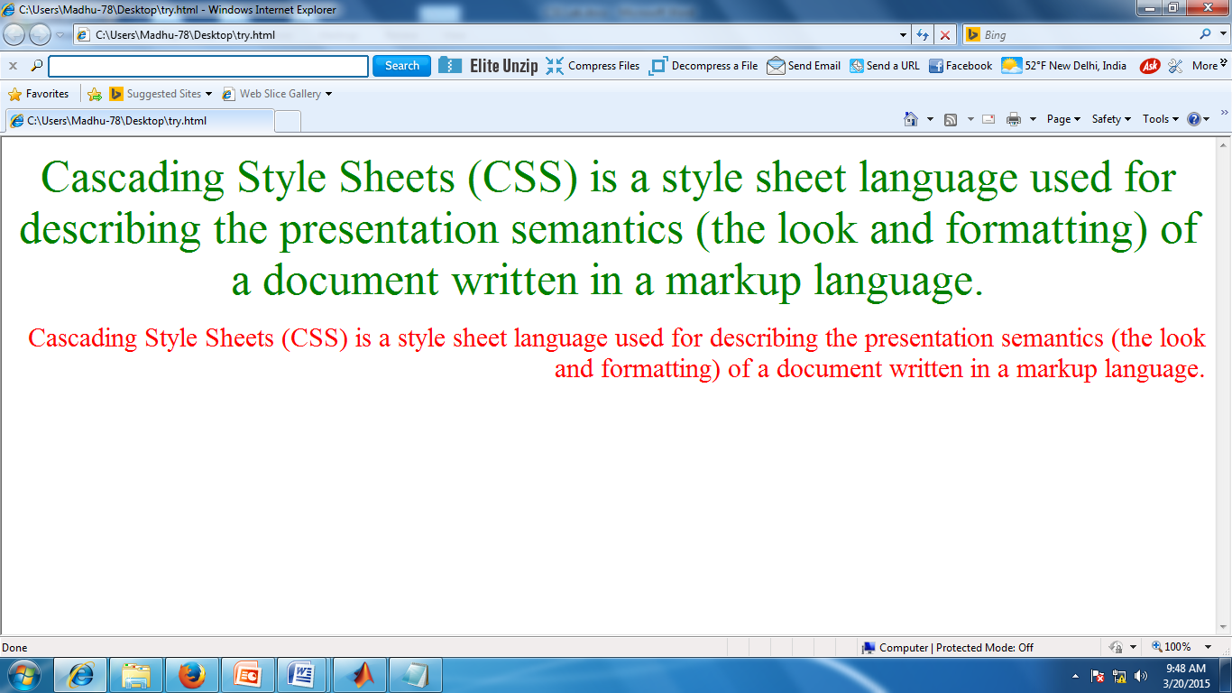

Ans 8.

<html>

<head>

<style type="text/css">

hr {color:red;}

h1,p {background-color:yellow;color:blue;}

</style>

<body>

<h1>Cascading Style Sheet</h1>

<p>

Cascading Style Sheets (CSS) is a style sheet language used

for describing the presentation semantics (the look and formatting)

of a document written in a markup language.

</p>

<hr>

</body>

</html>

